REST - Country Web Service
Create country controller and implement getCountryIndia()method
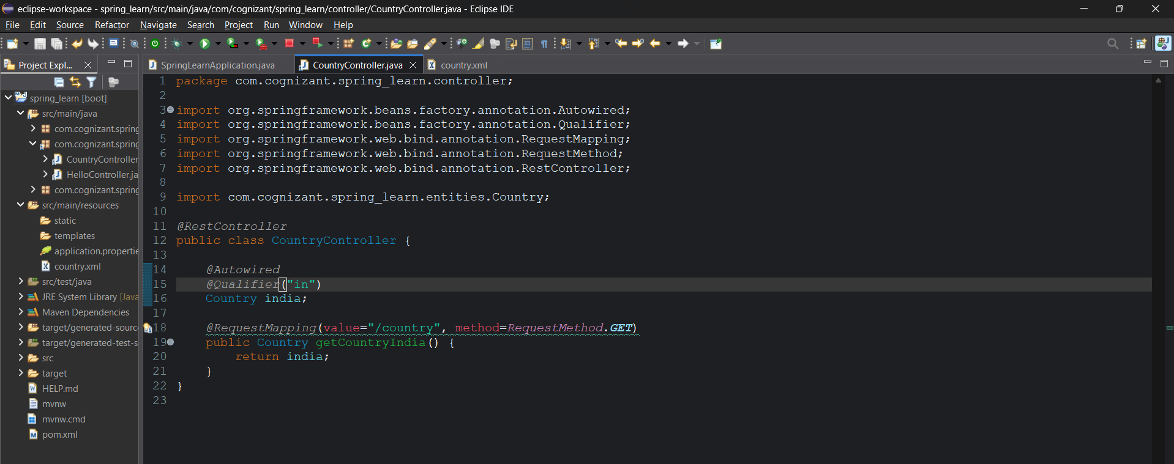
Since we have multiple countries in the configuration file we need to explicitly mention the bean name using the @Qualifier annotation.
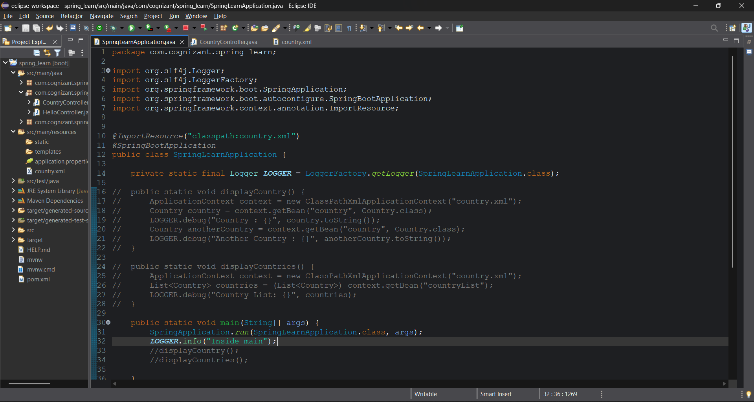
We have used @ImportResource because we need to load the configuration file
Previously we would be using the application context which loads the configuration file and load the beans but now here we haven’t used any application context.
That’s why we need to use that annotation
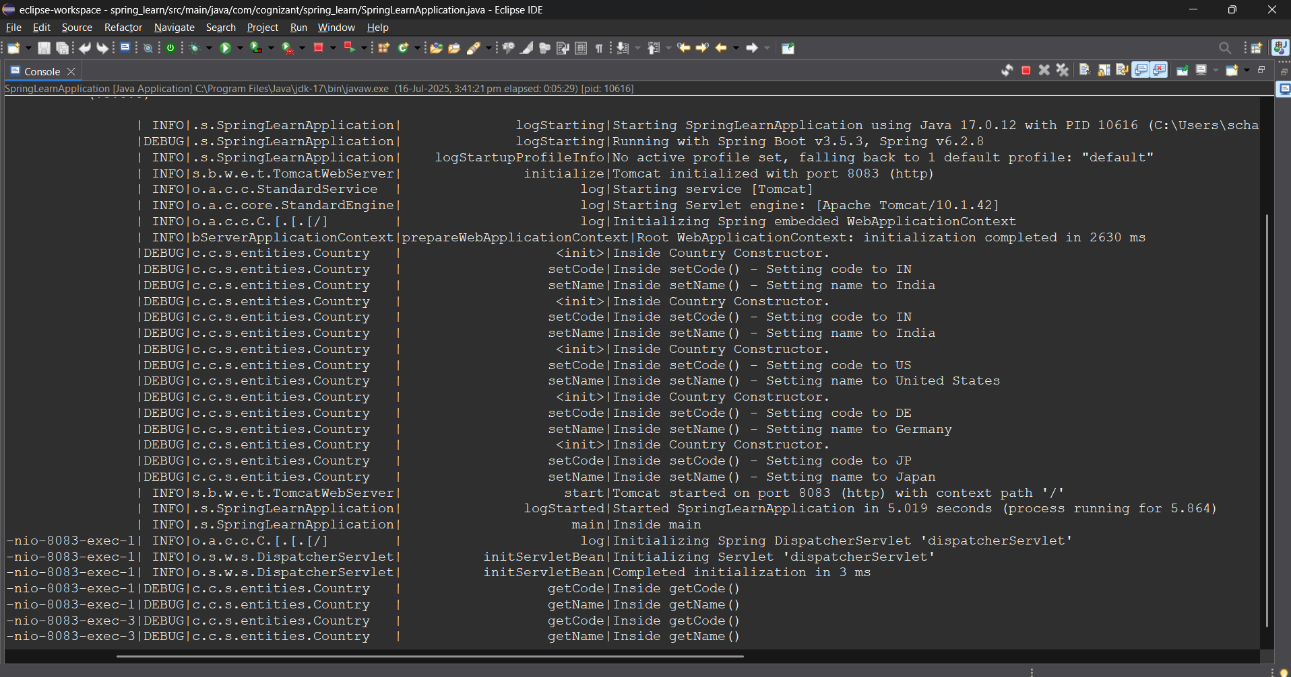
The server started at port 8083 and it loads all the beans of all countries
Postman:
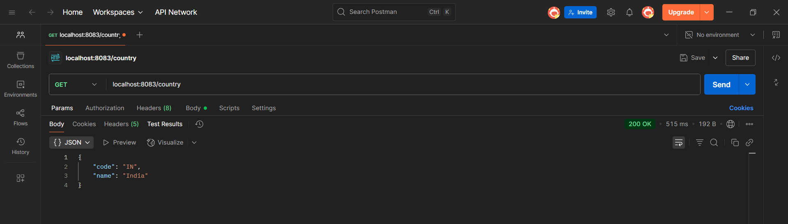
Browser:
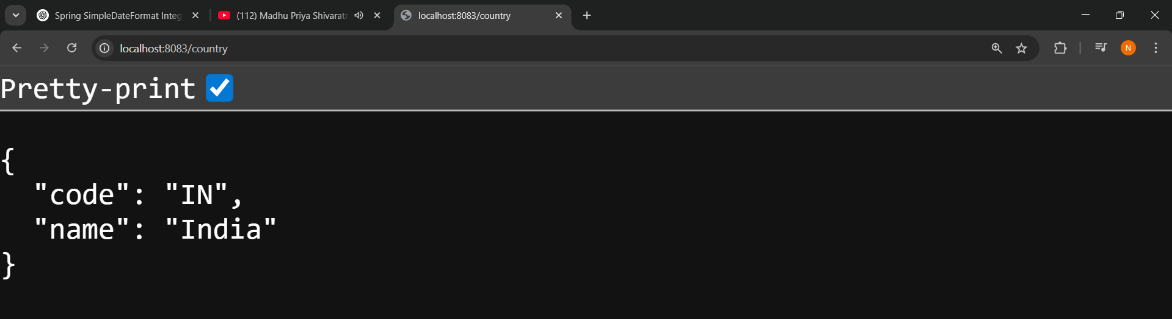
When we make request from postman/browser we get india object as response.

